Task on RDS

1.Create MariaDB DB on EC2.
sudo dnf update -y
sudo dnf install mariadb105-server -y
sudo systemctl enable mariadb
sudo systemctl start mariadb
sudo systemctl status mariadb
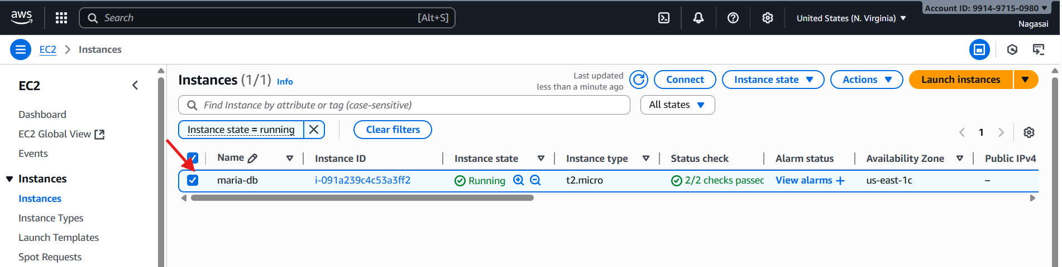
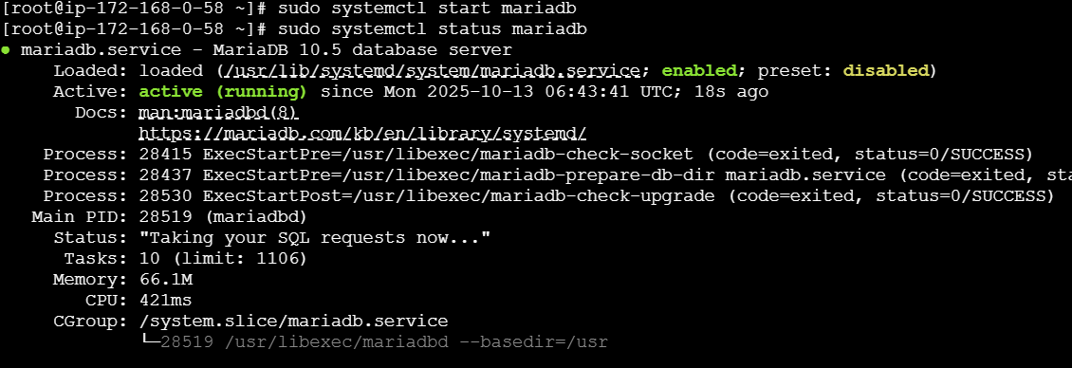
2.Insert some dummy data.
DBName=nagasaidb
DBPassword=admin123456
DBRootPassword=admin123456
DBUser=nagasaidbuser
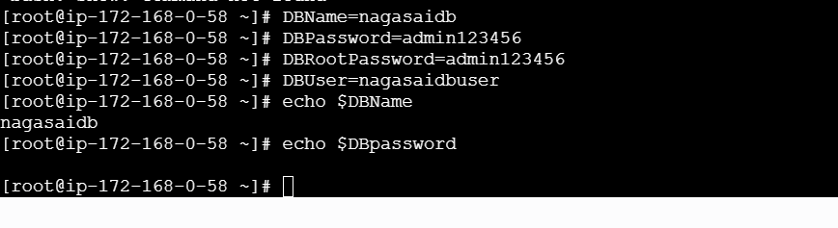
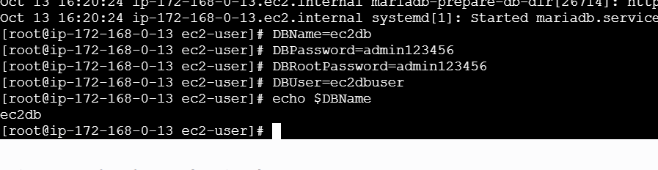

echo "CREATE DATABASE ${DBName};" >> /tmp/db.setupecho "CREATE USER '${DBUser}' IDENTIFIED BY '${DBPassword}';" >> /tmp/db.setup
echo "GRANT ALL PRIVILEGES ON *.* TO '${DBUser}'@'%';" >> /tmp/db.setup
echo "FLUSH PRIVILEGES;" >> /tmp/db.setup
mysqladmin -u root password "${DBRootPassword}"
mysql -u root --password="${DBRootPassword}" < /tmp/db.setup
rm /tmp/db.setup

mysql -u root --password="${DBRootPassword}"
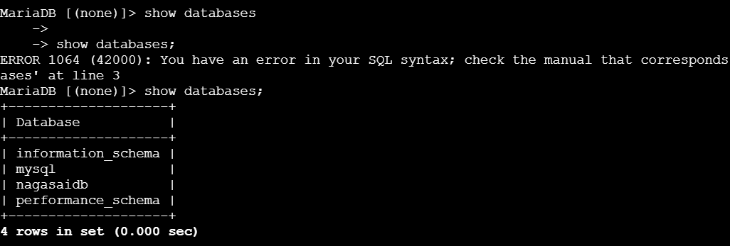
USE nagasaidb;
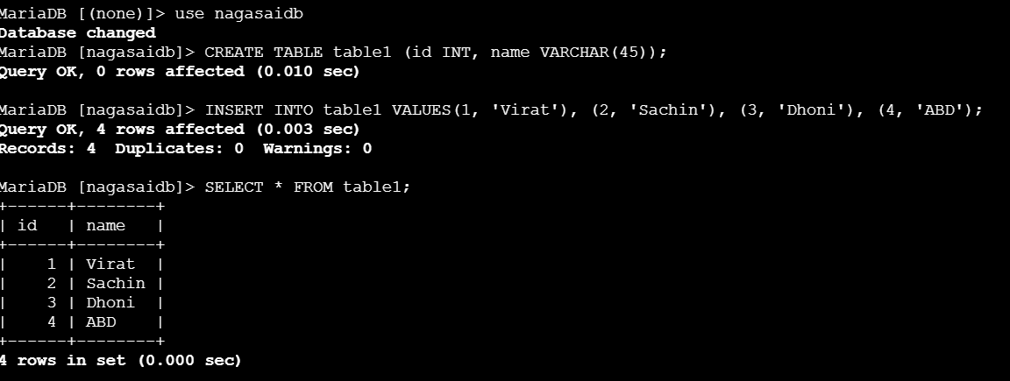

3.Take the backup of dummy data on EC2.
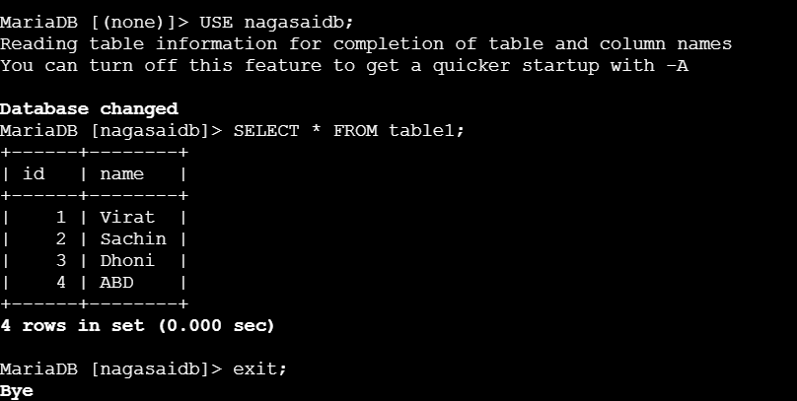
Take backup using mysqldump:
mysqldump -u root -p${DBRootPassword} ${DBName} > /home/ec2-user/${DBName}_backup.sql
check the backup file : ls -lh /home/ec2-user/nagasaidb_backup.sql
preview the file : head /home/ec2-user/nagasaidb_backup.sql
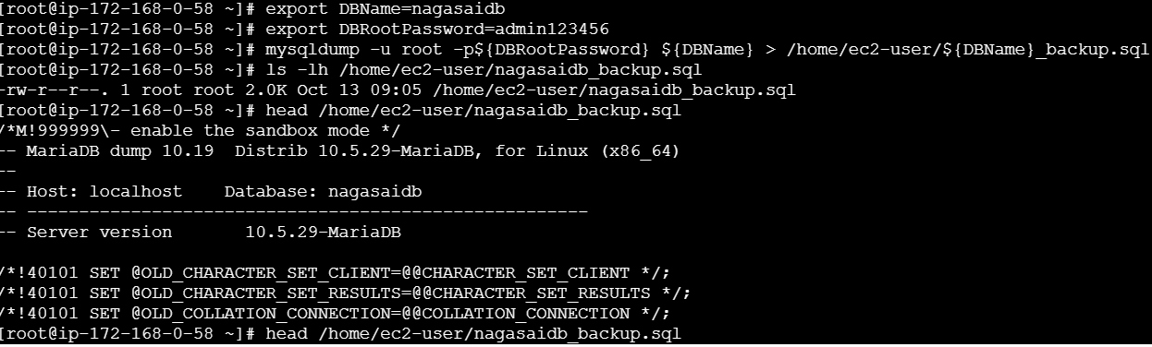
4.Launch MariaDB RDS instance.
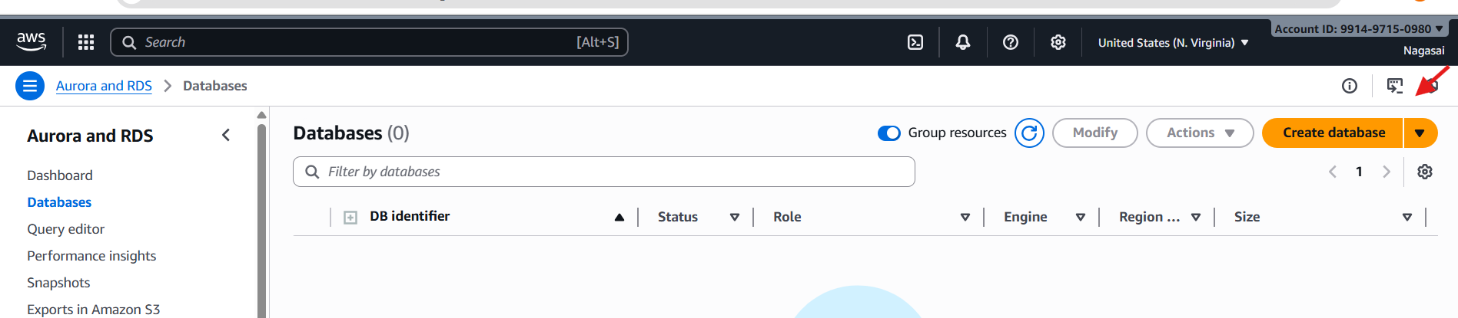
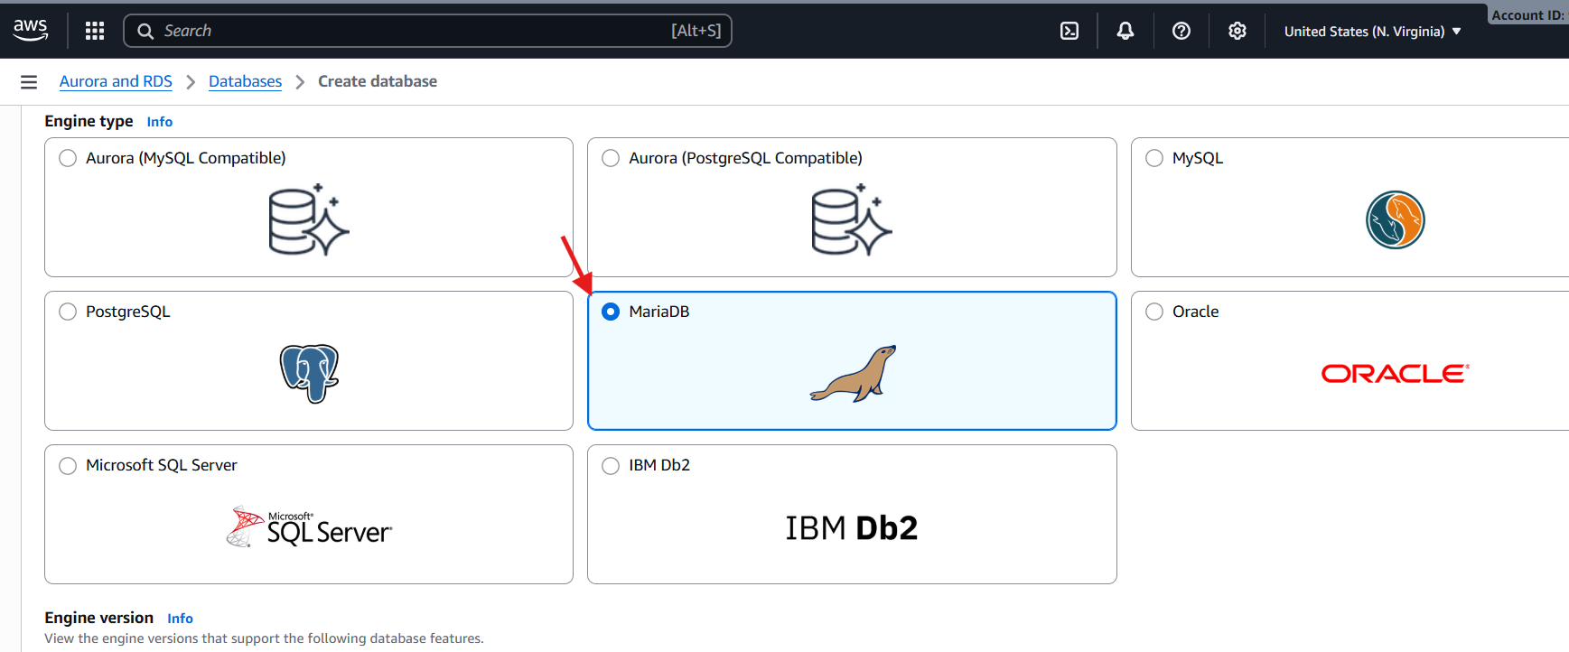
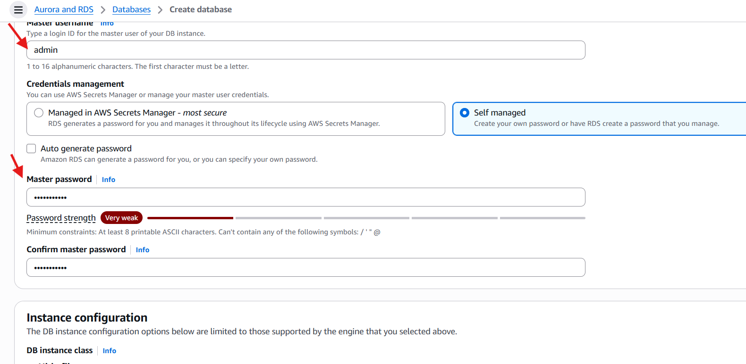
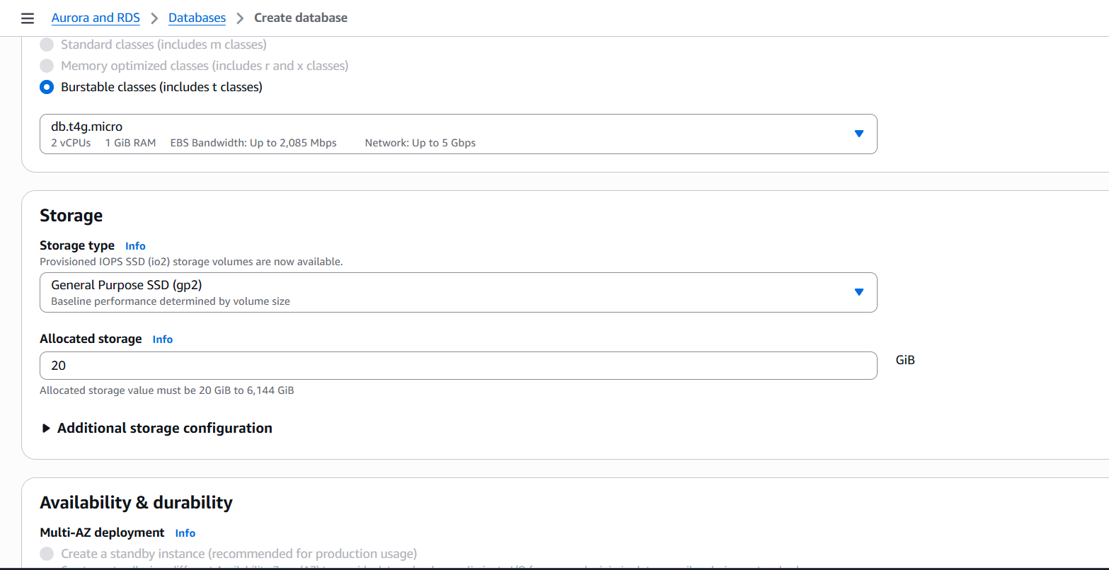
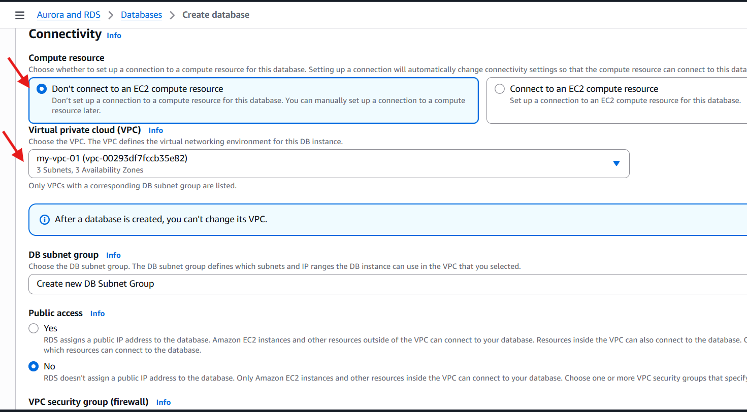
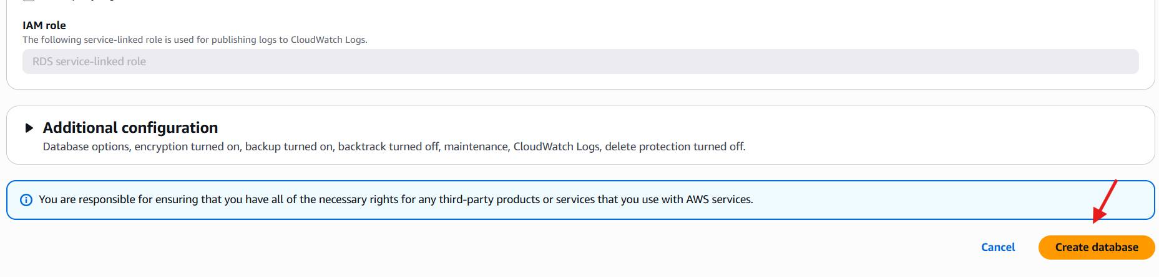
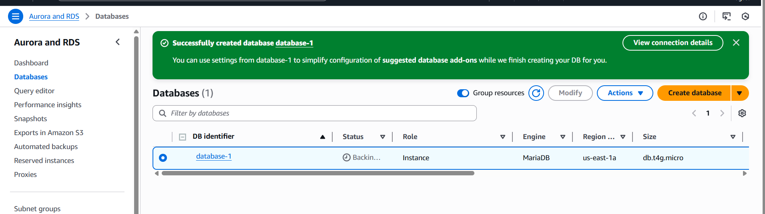
5.Migrate database from EC2 to RDS.
1) Get the dump of your existing DB on EC2
mysqldump -u root -p nagasaidb > nagasaidb.sql
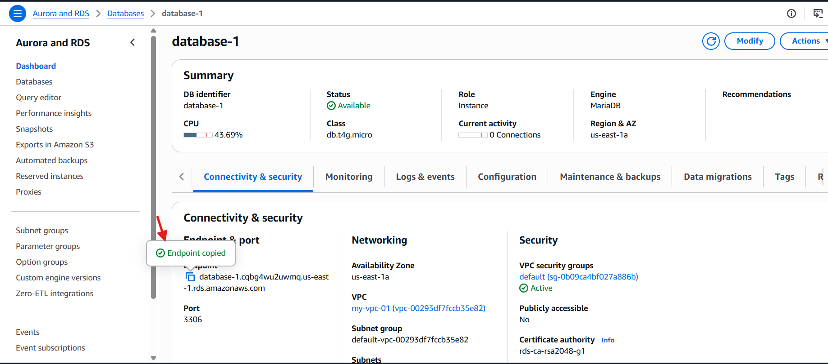
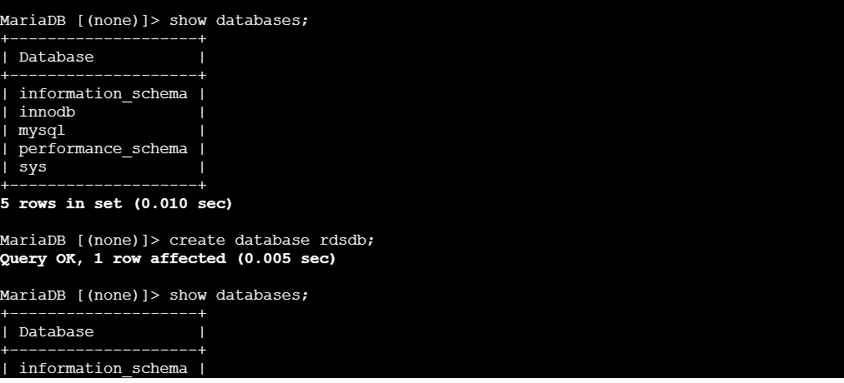
6.Install MySQL DB on EC2.
Remove Mariadb using following commands
sudo dnf remove -y mariadb105*
sudo dnf clean packagesStep 2: Goto /opt directory and run the following commands to download and install the MYSQL.
sudo wget https://dev.mysql.com/get/mysql80-community-release-el9-1.noarch.rpm
sudo dnf install mysql80-community-release-el9-1.noarch.rpm -y
sudo rpm --import https://repo.mysql.com/RPM-GPG-KEY-mysql-2023
sudo dnf install mysql-community-server -y
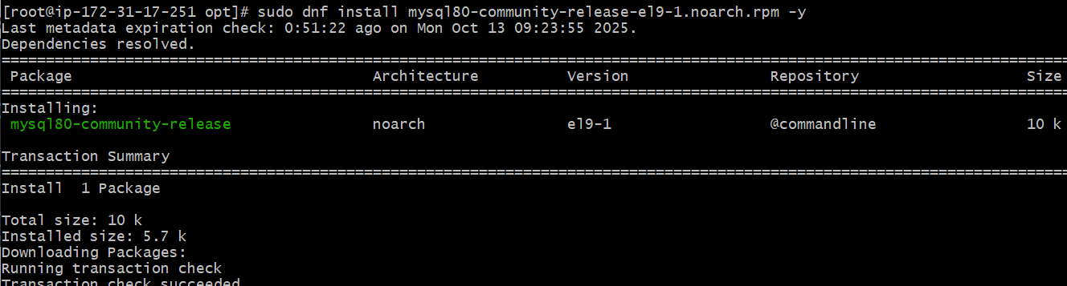
sudo systemctl start mysqld
sudo systemctl enable mysqld
sudo mysql_secure_installation
sudo systemctl status mysqld
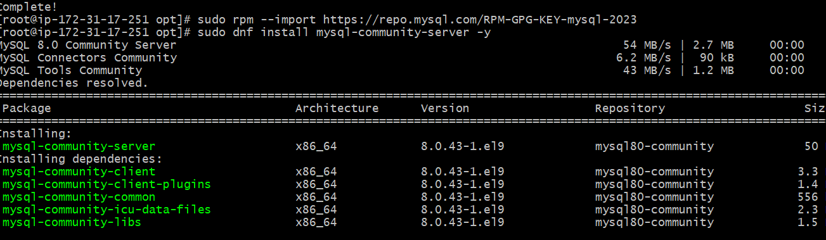

7.Launch MySQL RDS image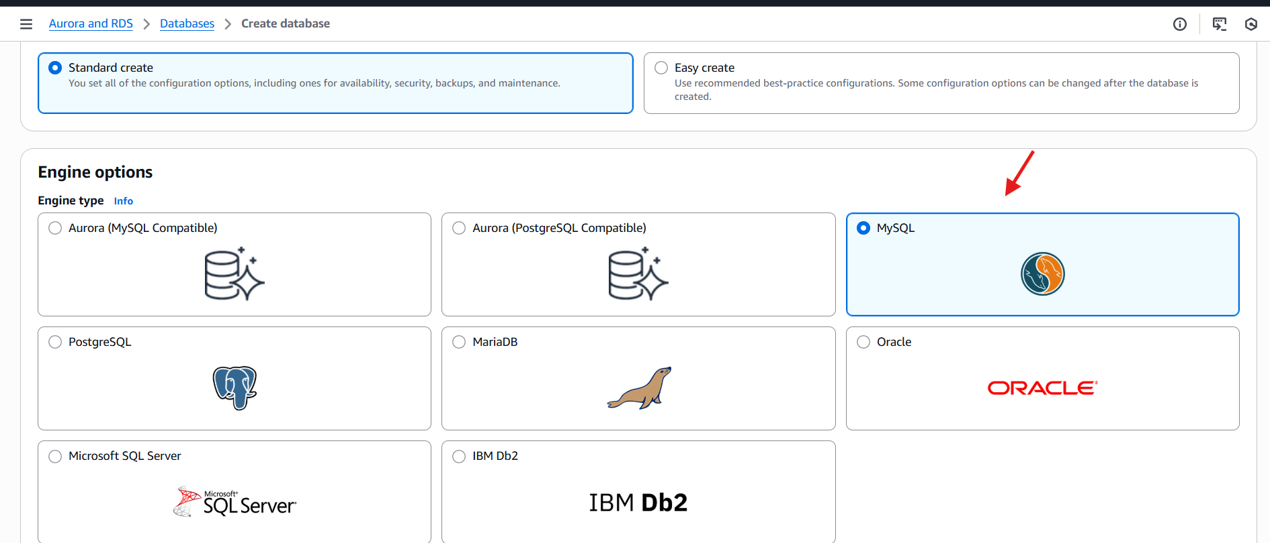
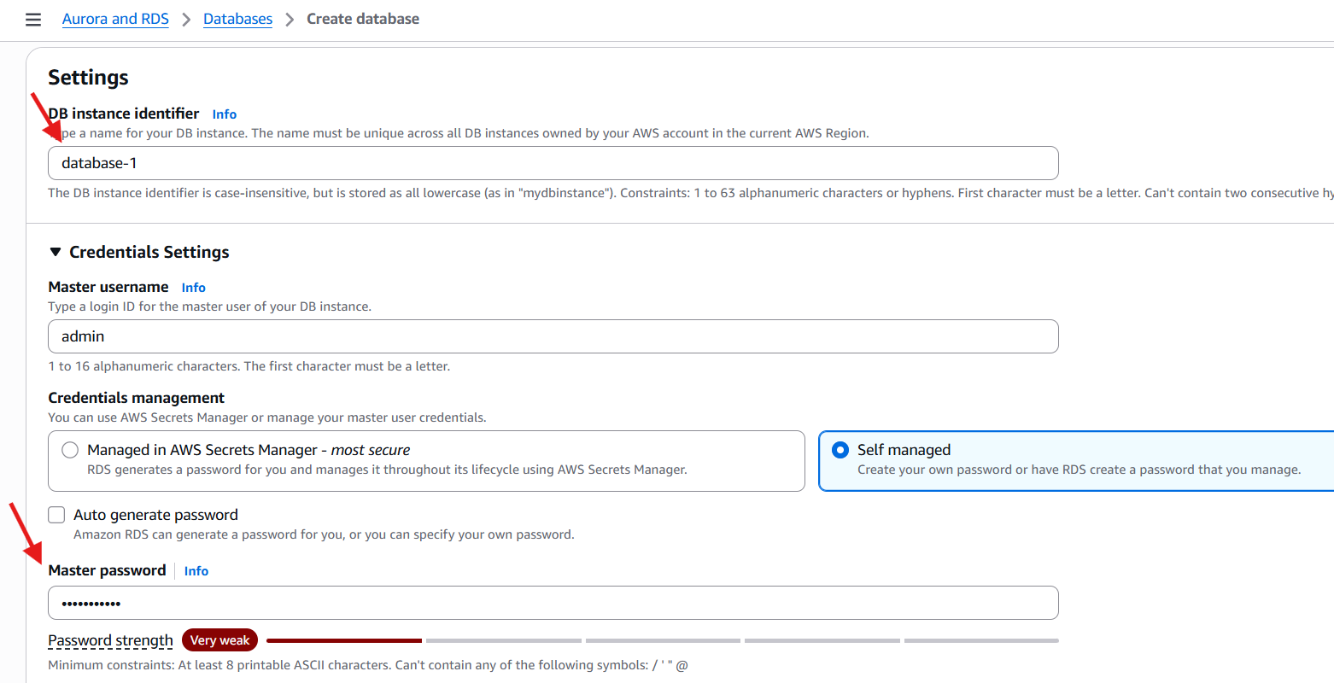
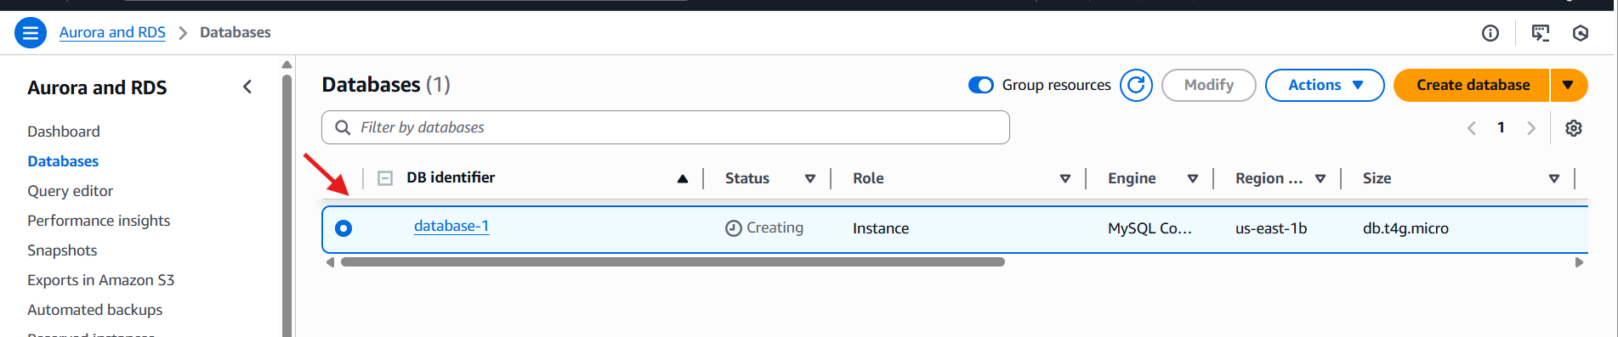
8.Configure Multi-AZ.
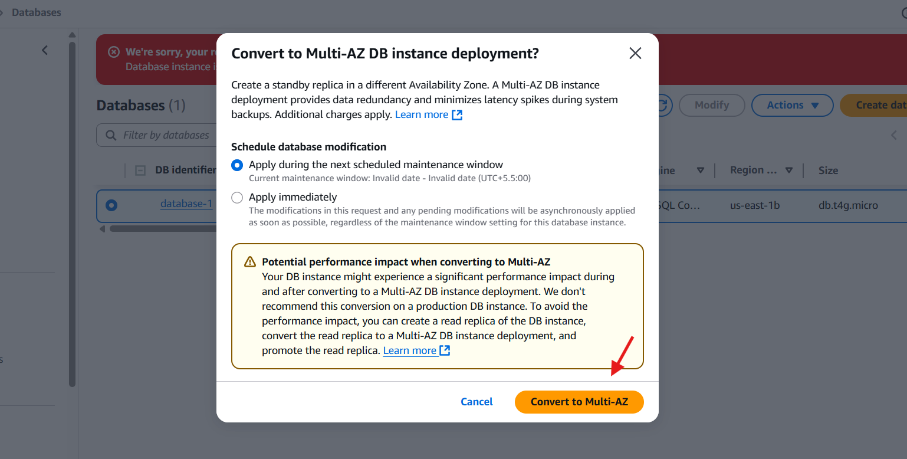
9.Take backup of DB and restore the DB.
Go to the RDS
Click on action and click on the snapshot
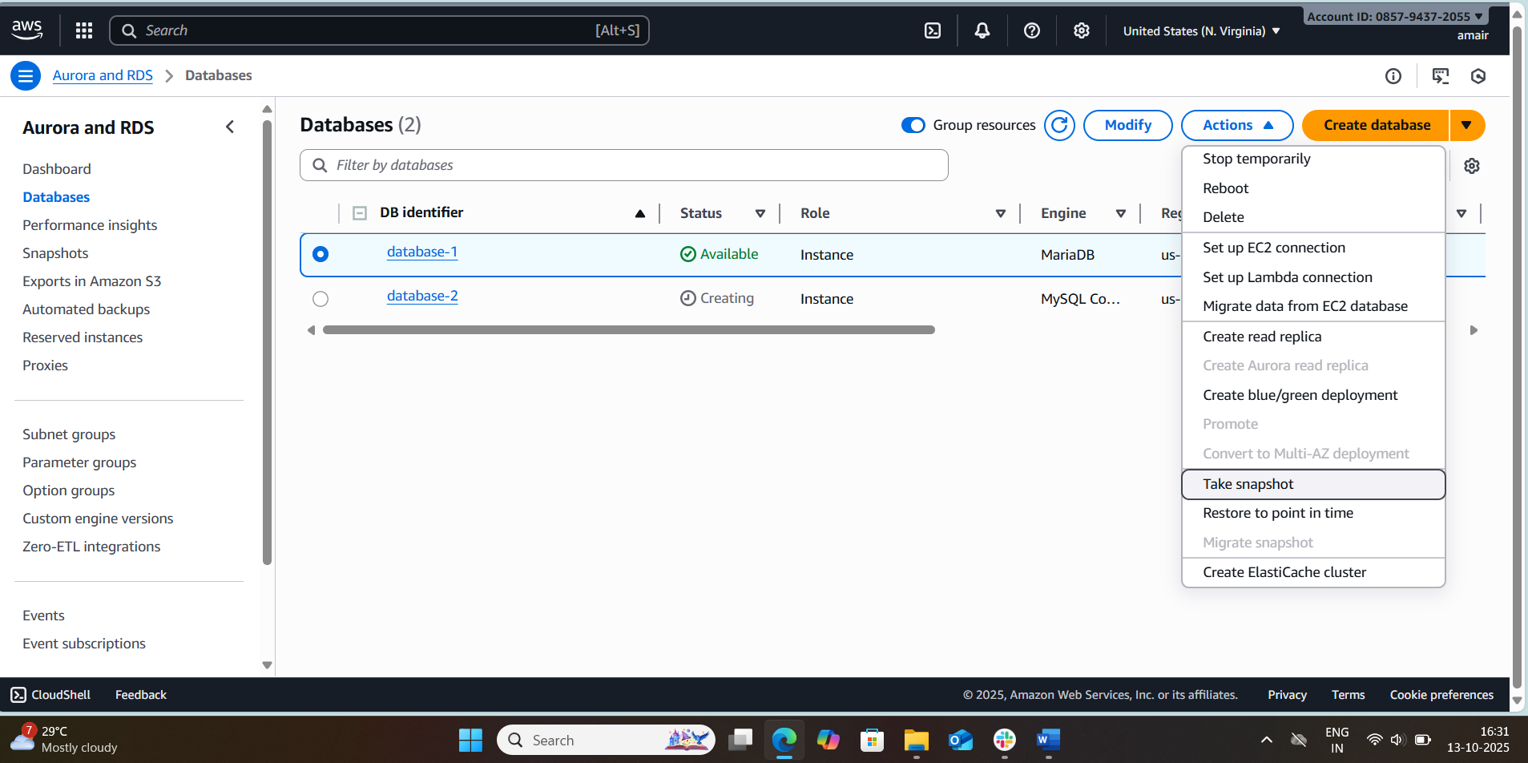
After taking snapshot delete the database.
Goto RDS select snapshot
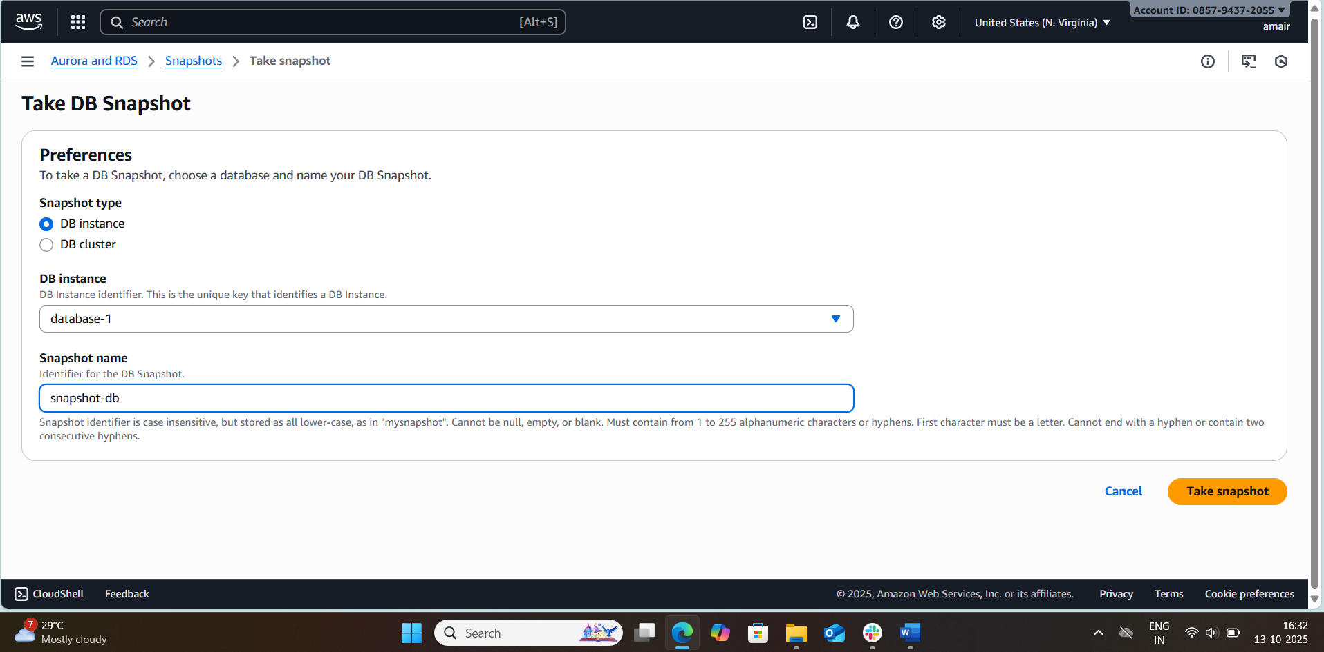
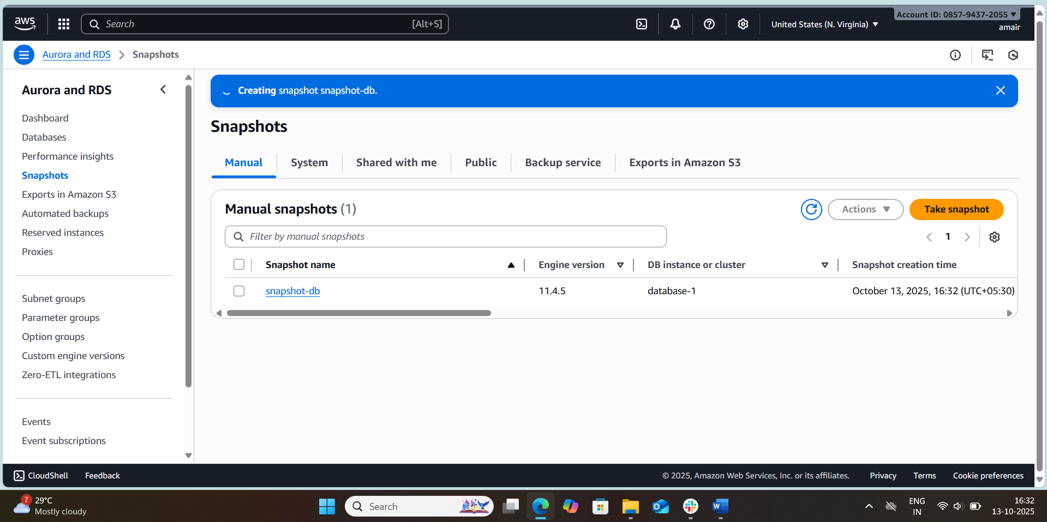
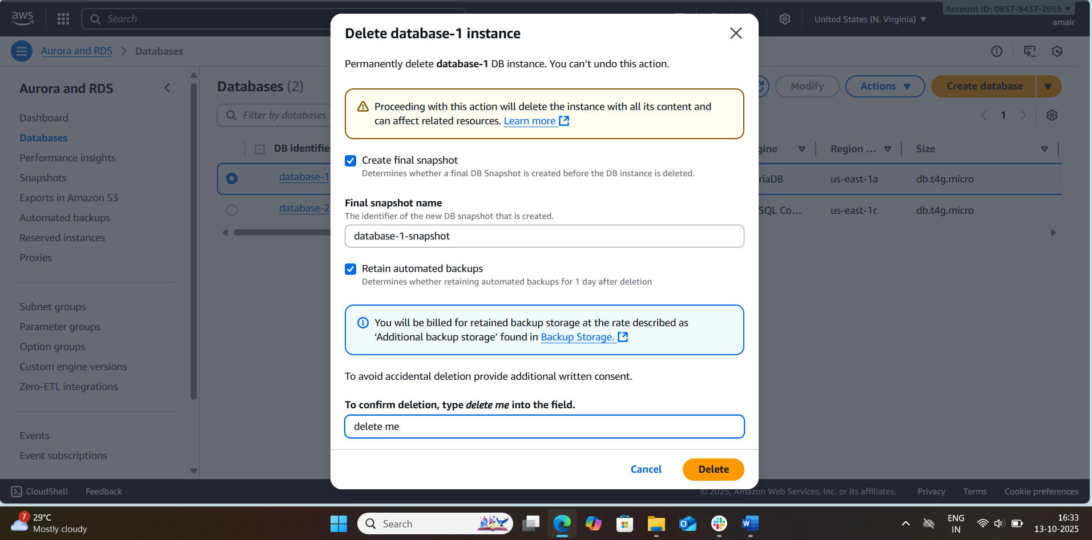
select your snapshot and go to Actions
click on restore snapshot

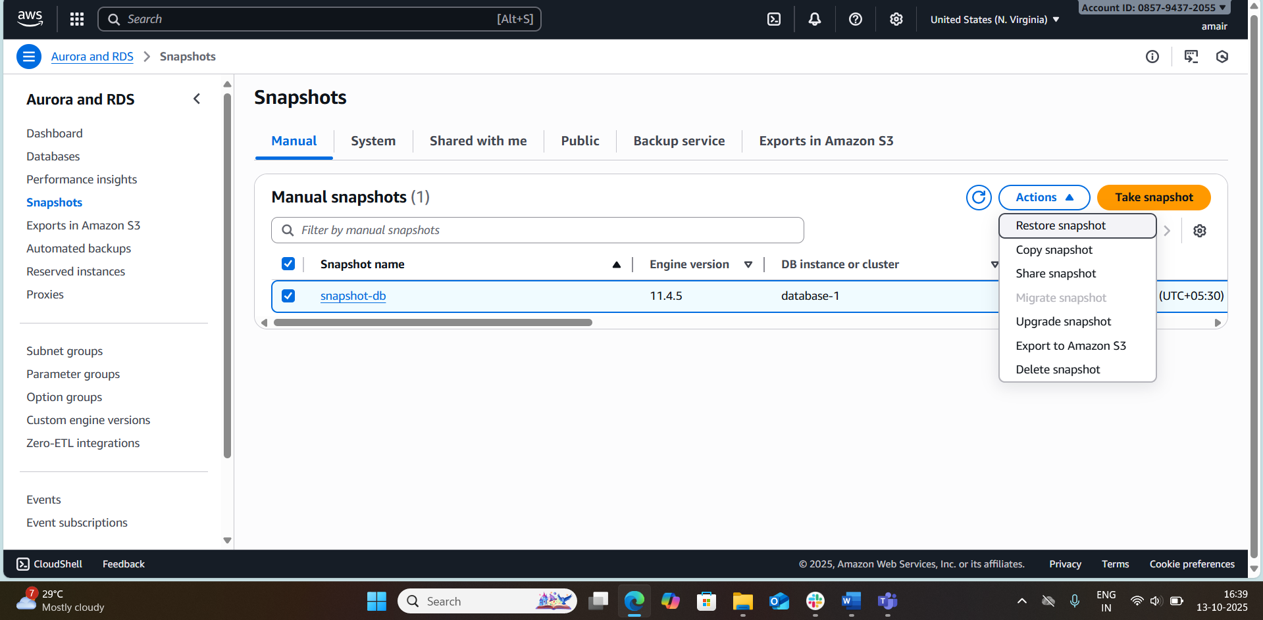

10.Create read replica.
